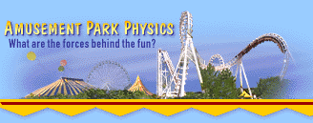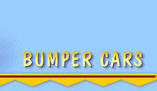
Bumper Cars
Newton's third law of motion comes into play on the bumper cars. This law, the law of interaction, says that if one body exerts a force on a second body, the second body exerts a force equal in magnitude and opposite in direction on the first body. It's the law of action-reaction, and it helps to explain why you feel a jolt when you collide with another bumper car.

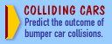
How do bumper cars work?
Bumper car rides are designed so that the cars can collide without much danger to the riders. Each car has a large rubber bumper all around it, which prolongs the impact and diffuses the force of the collision.

The bumper cars run on electricity, carried by a pole on the back of the car that leads up to a wire grid in the ride's ceiling. This grid carries the electricity that runs the car. Electrical energy carried to the cars from the grid is converted to kinetic energy, some of which is converted to heat.

What happens to the drivers?
When bumper cars collide, the drivers feel a change in their motion and become aware of their inertia. Though the cars themselves may stop or change direction, the drivers continue in the direction they were moving before the collision. This is why it's important to wear a seat belt while driving a real car, since otherwise you could suffer injury being thrown forward in a collision.
The masses of the drivers also affect the collisions. A difference in mass between two bumper car riders will mean that one rider experiences more change in motion than the other (or more of a jolt). The type of collision, velocity of the cars, and mass of the individual drivers all come into play in bumper car collisions.

© Annenberg Foundation 2013. All rights reserved
Retrieved from: http://www.learner.org/interactives/parkphysics/bumpcars.html

